**SAP Development Methods**

**Classical, In-App Extensions, BTP**

Document Control Information

|  |  |
| --- | --- |
| Document Identification |  |
| Document Name | **SAP Development Method Guide** |
| Project Name | **PROJECT** |
| Client | **Client** |
| Document Author | **Muthukumarasamy Arun (DTC)** |
| Document Version | **1.0** |
| Document Status |  |
| Date Released |  |

Document Edit History

| Version | Date | Additions/Modifications | Prepared/Revised by |
| --- | --- | --- | --- |
| 1.0 | 2022/10/27 | Initial draft |  |
|  |  |  |  |
|  |  |  |  |
|  |  |  |  |

Document Review/Approval History

| Date | Name | Organization/Title | Comments |
| --- | --- | --- | --- |
| 2022/12/16 |  | CLIENT |  |
|  |  |  |  |
|  |  |  |  |
|  |  |  |  |
|  |  |  |  |

Distribution of Final Document

The following people are designated recipients of the final version of this document:

| Name | Organization/Title |
| --- | --- |
| <Name> | <Organization/Title> |
|  |  |
|  |  |
|  |  |

Contents

1. SAP Development Methods 4

2. Upgrade Impact 6

3. DECISION TREES 7

4. TOOLS AND SERVICES 12

# SAP Development Methods

There are mainly 3 different SAP development methods,

1. *Classical Extensibility*,
2. *In-App Extensions* (Key User extensibility and Developer Extensibility) and
3. *Side by Side Extensibility* using BTP (Business Technology Platform)

In most cases, all extension types work hand in hand with

1. **Classical Extensibility:**

* Full access to the SAP S/4HANA ABAP backend, DB and Fiori frontend.
* Follows the same customization approach as previous SAP ERP suites. (Only available in S/4HANA On-Premises)
* SAP has always provided the flexibility to adjust the standard objects to cater to the business process needs, therefore SAP provided extension points at different levels and layers in the form of few of the following tools.
* Customer Exits
  + - Function module exit
    - Screen Exit
    - Menu Exit
* Business Transaction Events (BTE)
* Business Add-ins (BADIs)1
* Table Enhancements (Append structures) etc.

1. **S/4 In-App Extensions:**

In-App extensions is a combination of In-App Extensibility and Developer Extensibility as below, and both the activities will perform into S/4 HANA.

* **In-App Extensibility (Key User Extensibility):**
  + Key users (Business Experts, Implementation Consultants) using Key user tools, which help to identify “Fit Gap” in the loosely coupled fashion for the key user’s extensibility on task complexity level and features as below.
  + When the logic is simple then we can use easy user interface tools within S/4 HANA system as below to adjust to our business needs,
    - UI Adaptation (Show hide/arrange fields and sections on existing UI)
    - Personalization (Add remove filters, table fields)
    - Add/Manage custom fields
    - Adopt/Add reports, KPI’s and forms
    - Maintain forms and emails templates
    - Flexible workflows
* **Developer Extensibility:** 
  + When the logic is complex and required developer expertise then with the restricted ABAP, Developers do the extensions to create and change complex business logic, in this scenario’s developer can also use key-users’ tools in addition to modern IDE like.
    - BAS (Business Application Studio) (UI Adaptation using Adaptation project)
    - Debugging
    - Code check
    - Quality tools
    - Add business logic (In-App BADI’s with restricted ABAP)

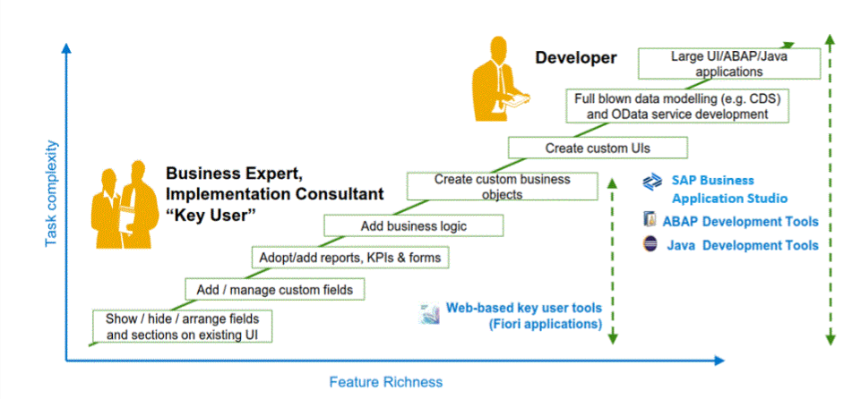

1. **Side-by-side Extensibility**:

* Customizations occur in an adjacent cloud application layer (BTP-Cloud PaaS) where S/4HANA is integrated and external content are consumed within solution.
* Extend application by building new apps on BTP, utilizing standard/custom APIs. With this approach standard solution and customer extension are completely decoupled.
* It is one platform for extending both cloud and on-premises solutions from SAP.
* It provides integration for your extensions on the UX, process, and data levels.
* It offers comprehensive security from the UI to the back end.
* It enables smooth connectivity to SAP solutions and easier discovery and consumption of APIs and events across applications.
* It is integrated into the lifecycle management of hybrid landscapes.

# Upgrade Impact

Below matrix gives idea of upgrade impact of on development objects.

|  |  |
| --- | --- |
| **Legends** | |
| Warning with solid fill | Caution (Break-Fix may be needed) |
|  | Acceptable (Regression test may be needed) |
| Checkmark with solid fill | Recommended (No impact) |

|  |  |  |  |  |
| --- | --- | --- | --- | --- |
| **RICEFW Objects** | **Classical** | **In-App Extensions**  **(Key User Extensibility)** | **In-App Extensions**  **(Developer Extensibility)** | **Side by side** |
| Data dictionary object  (Table, data element, domain) | Warning with solid fill |  |  | Checkmark with solid fill |
| Report | Warning with solid fill |  |  | Checkmark with solid fill |
| Enhancement * | Warning with solid fill |  | Warning with solid fill | Checkmark with solid fill |
| Interface (IDOC’s/File/Proxy) | Warning with solid fill | Not Applicable | Warning with solid fill | Checkmark with solid fill |
| Interface (IFlow) | Not Applicable | Not Applicable | Warning with solid fill | Checkmark with solid fill |
| Conversions  (BAPI, IDOC's) | Warning with solid fill | Not Applicable | Warning with solid fill | Not Applicable |
| Form | Warning with solid fill |  |  | Checkmark with solid fill |
| Workflow | Warning with solid fill |  | Warning with solid fill | Checkmark with solid fill |
| ODATA | Warning with solid fill |  | Warning with solid fill | Checkmark with solid fill |
| Standard Fiori App | Not Applicable |  | Warning with solid fill | Checkmark with solid fill |
| Custom Fiori App | Not Applicable | (With UI adaptation) |  | Checkmark with solid fill |
| BRF+ | Not Applicable |  |  | Checkmark with solid fill |
| CDS View | Warning with solid fill |  |  | Checkmark with solid fill |
| Screen Personna | Not Applicable |  |  | Checkmark with solid fill |
| SAP S/4HANA Embedded Analytics | Warning with solid fill |  |  | Not Applicable |
| SAP Analytics Cloud | Not Applicable | Not Applicable | Not Applicable | Checkmark with solid fill |

**\*Enhancement: SAP Enhancement**concept allows customer to add own functionality to SAP standard business applications without having to modify the original applications. User Exits, Customer Exits (Function module exit, Screen Exit, Menu Exit), Implicit & Explicit enhancement, Business Transaction Events (BTE), Table Enhancements (Append Structure) & BADI’s part of that **Enhancement**concept.

# DECISION TREES

Below Decision trees are covering all SAP available and possible RICEFW objects and scenarios for the extensibility as below**.**

* **Reports**

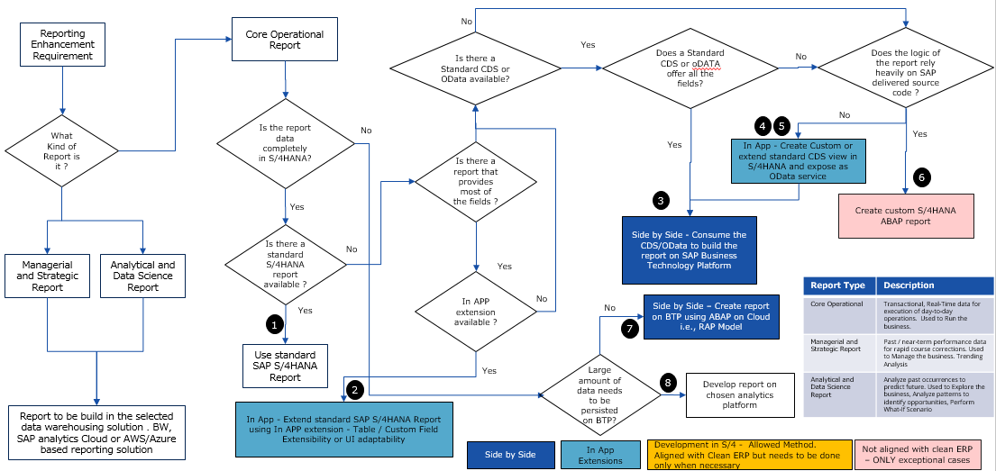

* **CPI Interfaces**

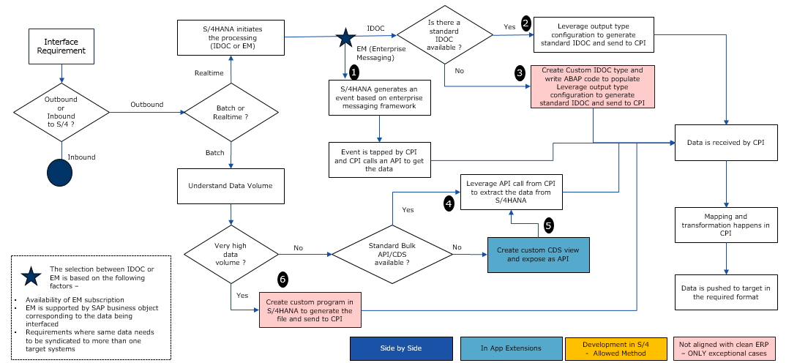

* **Forms**

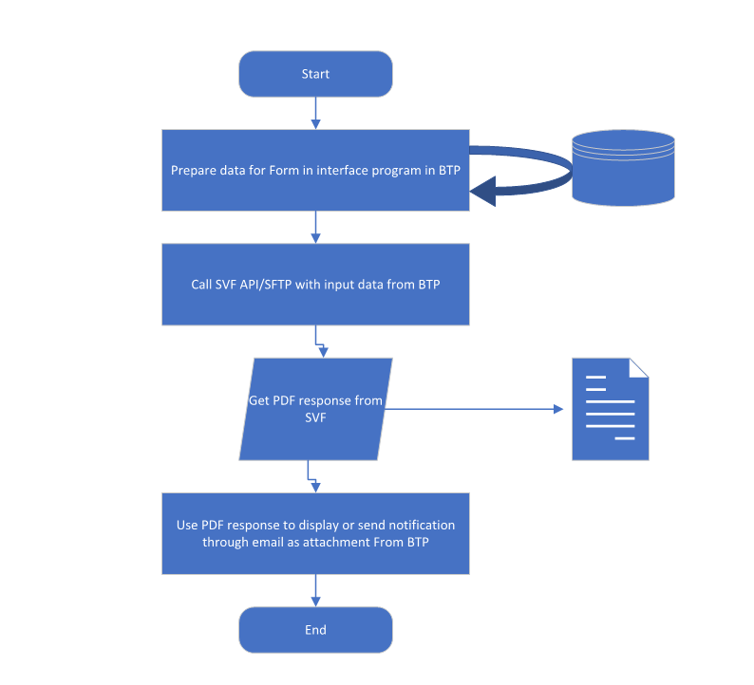

* **Workflows**

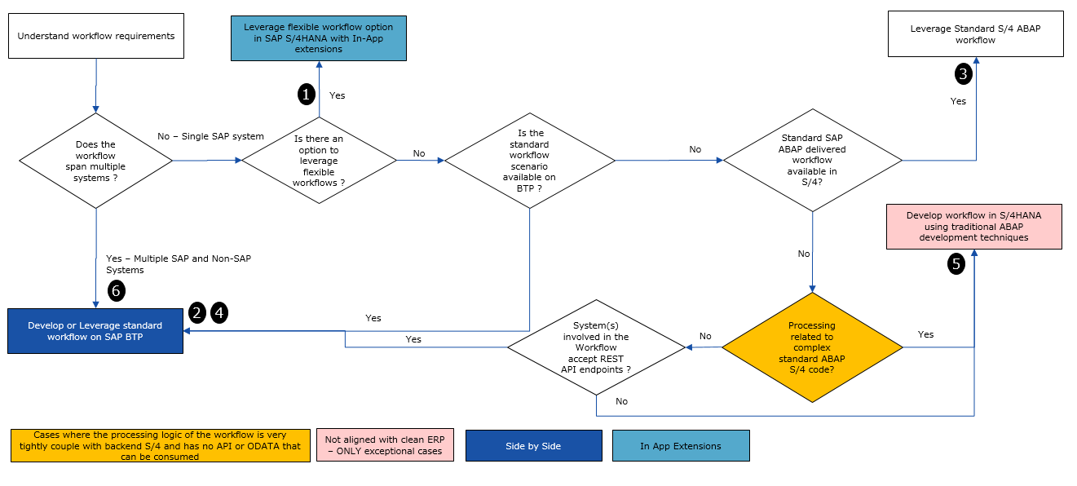

* **Table / Custom Field Extensions**

If a requirement is to add and edit custom fields to extend database tables, CDS views and OData APIs so we can follow.

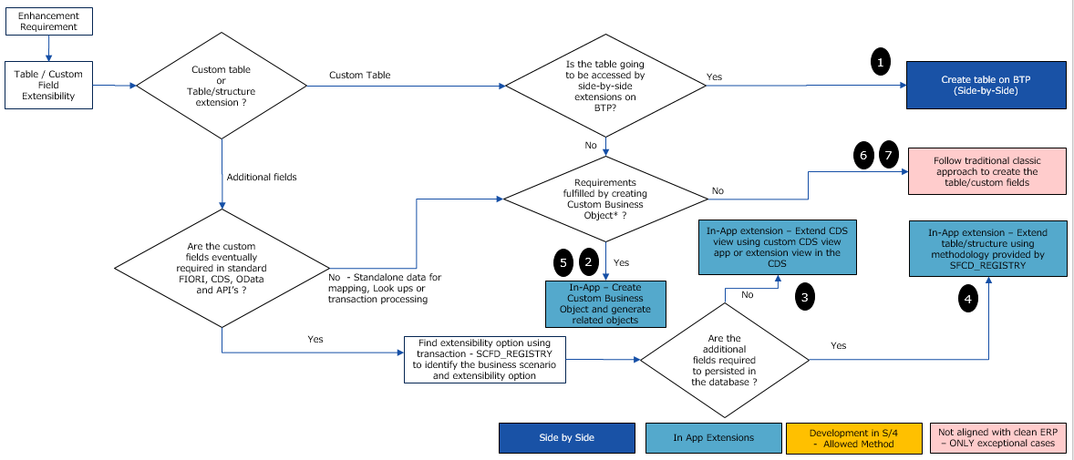

* **CDS Views Extensions**

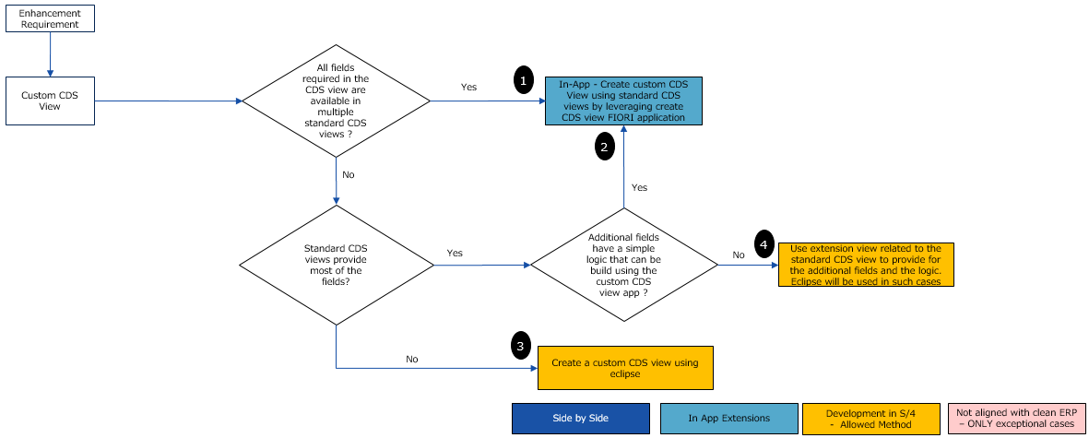

* **Business Logic Extensions** (Extend / Change Business functionality within the S/4HANA application based on business requirements)

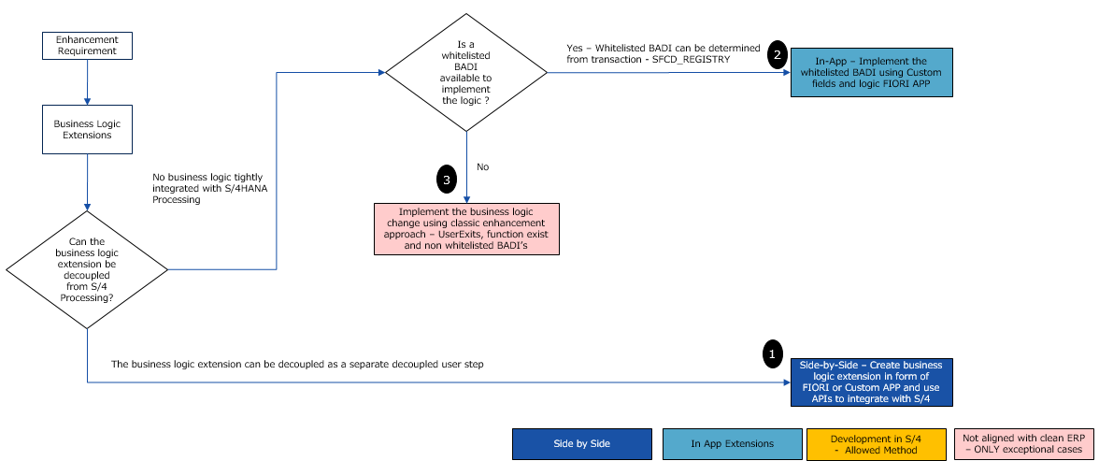

* **API’s or OData Extensions** from/to read or post data from/to S/4HANA (Outbound and Inbound)

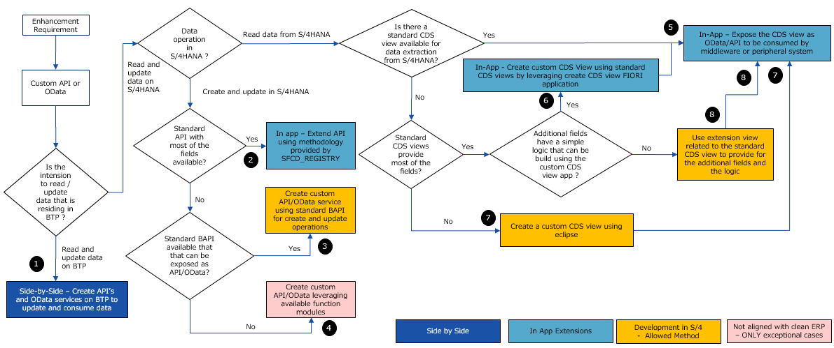

# TOOLS AND SERVICES

| Object Type | Classical Extensibility | S/4 In-App Extensibility | BTP (Side-by-Side) Extensibility |
| --- | --- | --- | --- |
| Reports | * SE38 * SE80 | * Business Application Studio (BAS) * Custom Fields and Logic * Eclipse ADT * Embedded Analytics Report   + Custom Analytical Queries Application   + Manage KPIs and Reports   + APF Configuration Modeler   + Query Browser | * Business Application Studio (BAS) * Restful ABAP Programming (RAP) * Cloud Application Programming   Eclipse ADT |
| Interfaces (API’s/OData, IDOC’s Extensions | * SE80 * SEGW * WEXX(WE*) * Eclipse ADT | * Eclipse ADT * SEGW * SFCD_REGISTRY * CPI | * Integration Suite * Event Mesh * CPI * Cloud Connector * Job Scheduling service |
| Forms | * SE71 (SAP Scripts) * SMARTFORMS * SFP (Adobe Forms) | * Maintain Form Templates App * Adobe Lifecycle Designer | * Forms by Adobe Service |
| Workflows | * SWDD * PFTC * PFAC * PFCG * SWIA * SWI1 * SWE2 * SWEL * SWELS * SWO1 * SE24 | * Manage Workflow Application (Flexible Workflows) * My Inbox App * Manage Teams and Responsibilities App | * Workflow Management Service * Business Application Studio (BAS) * Process flexibility application * Task Centre App/My Inbox App/ * Business rule service * XSUAA Service |
| Table / Custom Field Extensions | * SE11 * SE80 | * SFCD_REGISTRY * Custom Fields and Logic Application | * SAP Extensibility Explorer * Eclipse ADT |
| CDS Views | * Eclipse ADT | * SFCD_REGISTRY * Custom CDS Views App | * SAP Extensibility Explorer * Eclipse ADT |
| Business Logic Extensions (Badi’s, Customer Exits, User Exit etc.) | * Se80 * SE18/SE19 * CMOD/SMOD | * SFCD_REGISTRY * Custom Fields and Logic Application | * SAP Extensibility Explorer * Business Application Studio (SAPUI5/Fiori Apps- Fiori Elements) * CAP(NodeJS) * RAP |
| Business Objects (Table + ODATA) | * SE11 * SEGW | * SFCD_REGISTRY * Custom Business Objects Application | * SAP Extensibility Explorer * Eclipse ADT |
| UI Extensions | * SE51 * SE80 | * Business Application Studio (BAS) * UI Adaptation * SAP Screen Personas for Web Dynpro /UI5 apps | * BAS * UI Flexibility * AppGyver (Low Code/No-Code) |
| Emails | * SOST * SE80 | * Maintain Email Templates | * BTP Workflow Service |
| Cloud Application Programming Model (Java, Nodes JS, Spring etc.) | * N/A | * N/A | * SAP Cloud SDK (Service SDK’s) * Business Application Studio (BAS) * Eclipse ADT |
| Restful ABAP Programming Model (ABAP) | * N/A | * N/A | * Business Application Studio (BAS) * Eclipse ADT |
| Migration | * LSMW * BDC | * LTMC * Migration Cockpit | * Migration Cockpit (In-Conjunction with HANA DB) |
| SAP S/4HANA Embedded Analytics | * SE80 * Eclipse ADT | * UI Adaptation * SAP Fiori extensibility apps for the Analytics Specialist | * N/A |
| **SAP Analytics Cloud** (SAP Analytics Cloud is an all-in-one cloud product offered as software as a service (SaaS) for business intelligence (BI), planning, and predictive analytics. Built natively on SAP BTP, it provides a unified and secure public cloud experience to maximize data-driven decision making) | * N/A | * N/A | * Analytics Designer, Modeler in SAC BTP |